A Project Report
On
Soil Testing and Crop Recommendation
submitted for partial fulfillment of the requirements
for the award of the degree of
Bachelor of Technology
in
Computer Science
Submitted by
Sanjeev Kumar (2000290120133)
Rahul Singh (2000290120122)
Priyanshu Kumar (2000290120118)
Under supervision of
Prof. Anurag Mishra

KIET Group of Institutions, Ghaziabad
Dr. A.P.J. Abdul Kalam Technical University, Lucknow
May, 2024
DECLARATION
We hereby declare that this submission is our own work and that, to the best of our knowledge and belief, it contains no material previously published or written by another person nor material which to a substantial extent has been accepted for the award of any other degree or diploma of the university or other institute of higher learning, except where due acknowledgment has been made in the text.

Signature Signature Signature
Name:- Sanjeev Kumar Name:- Rahul Singh Name:- Priyanshu Kuamr
Roll No.:- 2000290120133 Roll No.:- 2000290120122 Roll No.:- 2000290120118
Date:-

CERTIFICATE

This is to certify that Project Report entitled “ Soil Testing and Crop Recommendation ” which is submitted by Sanjeev Kuamr, Rahul Singh, Priyanshu Kumar in partial fulfillment of the requirement for the award of degree B. Tech. in Department of Computer Science of Dr. A.P.J. Abdul Kalam Technical University, Lucknow is a record of the candidates own work carried out by them under my supervision. The matter embodied in this report is original and has not been submitted for the award of any other degree.
.

Date: Supervisor
Anurag Mishra
(Professor)

ACKNOWLEDGEMENT

It gives us a great sense of pleasure to present the report of the B. Tech Project undertaken during B. Tech. Final Year. We owe special debt of gratitude to Professor Anurag Mishra, Department of Computer Science, KIET, Ghaziabad, for his/her constant support and guidance throughout the course of our work. His/Her sincerity, thoroughness and perseverance have been a constant source of inspiration for us. It is only his cognizant efforts that our endeavors have seen light of the day.
We also take the opportunity to acknowledge the contribution of Dr. Ajay Shrivastava, Head of the Department of Computer Science, KIET, Ghaziabad, for his full support and assistance during the development of the project. We also do not like to miss the opportunity to acknowledge the contribution of all the faculty members of the department for their kind assistance and cooperation during the development of our project.
Last but not the least, we acknowledge our friends for their contribution in the completion of the project.
Date :
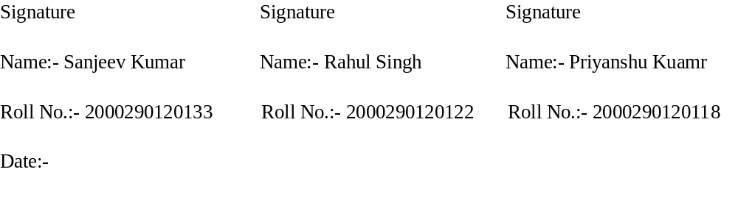

ABSTRACT

Soil is a crucial natural resource with profound economic and ecological implications. This research paper explores the potential of artificial intelligence (AI) to revolutionize soil testing and fertilizer recommendations, ultimately enhancing agricultural sustainability. We discuss the challenges posed by inefficient fertilizer use and the importance of soil testing in optimizing crop yields. The paper outlines the objectives, methods, and results of our study, which leveraged machine learning algorithms to predict crop yields based on soil quality. By analyzing data from various sources, we demonstrate the significant impact of AI-driven recommendations on cost-benefit ratios for farmers and the sustainable utilization of soil resources. Our findings underscore the importance of balanced nutrient management and highlight the role of AI in shaping the future of agriculture.

TABLE OF CONTENTS | Page No.
DECLARATION……………………………………………………………………. | ii
CERTIFICATE……………………………………………………………………… | iii
ACKNOWLEDGEMENTS…………………………………………………………. | iv
ABSTRACT………………………………………………………………………..... | v
LIST OF FIGURES…………………………………………………………………. | ix
LIST OF TABLES…………………………………………………………………… | xi
LIST OF ABBREVIATIONS………………………………………………………. | xii
CHAPTER 1 INTRODUCTION PAGE NO.
1.1 INTRODUCTION TO PROJECT
1.2 PROJECT CATEGORY(INTERNET BASED, APPLICATION OR SYSTEM DEVELOPMENT, RESEARCH BASED ,INDUSTRY AUTOMATION, NETWORK OR SYSTEM ADMINISTRATION)
1.3 OBJECTIVES
1.4 PROBLEM FORMULATION
1.5 PROPOSED SYSTEM
1.6 UNIQUE FEATURES OF THE SYSTEM

CHAPTER 2. REQUIREMENT ANALYSIS AND SYSTEM SPECIFICATION
2.1 FEASIBILITY STUDY (TECHNICAL, ECONOMICAL, OPERATIONAL)
2.2 SOFTWARE REQUIREMENT SPECIFICATION DOCUMENT WHICH MUST INCLUDE THE FOLLOWING:
(DATA REQUIREMENT, FUNCTIONAL REQUIREMENT, PERFORMANCE REQUIREMENT
, MAINTAINABILITY REQUIREMENT, SECURITY REQUIREMENT)
2.3 SDLC MODEL TO BE USED

CHAPTER 3. SYSTEM DESIGN
3.1 DETAIL DESIGN
3.2 SYSTEM DESIGN USING DFD LEVEL 0 AND LEVEL 1
3.3 USE CASE DIAGRAM
3.4 DATABASE DESIGN
3.4.1 ER DIAGRAMS

CHAPTER 4. IMPLEMENTATION, TESTING, AND MAINTENANCE
4.1 INTRODUCTION TO LANGUAGES,TOOLS AND TECHNOLOGIES USED FOR IMPLEMENTATION
4.2 TESTING TECHNIQUES AND TEST CASES USED

CHAPTER 5. RESULTS AND DISCUSSIONS
5.1 USER INTERFACE REPRESENTATION (OF RESPECTIVE PROJECT)
5.1.1 BRIEF DESCRIPTION OF VARIOUS MODULES OF THE SYSTEM
5.2 SNAPSHOTS OF SYSTEM WITH BRIEF DETAIL OF EACH
5.3 BACK ENDS REPRESENTATION (DATABASE TO BE USED )
5.3.1 SNAPSHOTS OF DATABASE TABLES WITH BRIEF DESCRIPTION
CHAPTER 6. CONCLUSION AND FUTURE SCOPE

REFERENCES( REFERENCES SHOULD BE IN IEEE STANDARD)
LIST OF FIGURES

Figure No. | Description | Page No.
3.1 | Detain Design | 9
3.2 | 0 Level DFD | 9
3.2  3.3 | 1 Level DFD  Use Case Diagram | 10  10

CHAPTER 1
INTRODUCTION

1.1 INTRODUCTION

A soil test is a process by which elements (nitrogen, phosphorus, potassium) which are present in the soil are measured for their "plant available" content within the sample. The quantity of available nutrients in the sample determines the amount of fertilizer that is recommended. A soil test also measures soil pH.
The soil is a vital natural resource which provides food to all living creatures in nature. The soil is basis of life in nature. A good quality soil can produce large amount food.
The use fertilizer helps in increasing the production of food to meet the demand by the whole world. As the population is increasing day by day the demand for the food is also increasing. But land available for the cultivation and production of crop is limited. This causes to utilize the full potential of land to produce food. And the fertilizer and pesticides help in producing the food.
But due to use excessive or less use of fertilizer the nutrients in the soil for crop keeps decreasing which eventually causes less production of food. To avoid this problem correct measure of nutrients available and needed by the soil for a particular soil should be done. Which helps crops to grow fast and healthy.
Crop also get affected by the disease which destroy the whole field. If right pesticides are used at the right time by
detecting the type of pest that affecting the crop, loss of crop can be reduced.

1.2 PROJECT CATEGORY

The project is categorized under "Industry Automation," focusing on revolutionizing agriculture. Through IoT, AI, and machine learning, it automates soil testing, crop recommendations, and decision-making processes. This automation increases efficiency and productivity while ensuring precise management of resources. By integrating advanced technologies, the project enhances agricultural practices, promoting sustainability and resilience in the face of evolving challenges.

1.3 OBJECTIVES

- The main objective is to evaluate the fertility and nutrients status in the given soil and provide a recommendation on the amount of manure and fertilizer based on soil test value and according to crop.

- To avoid excess use of fertilizer and to ensure environmental safety.

- To test the soil timely, because each time when a crop a is harvested from the field, the soil losses a considerable amount of nutrients and causes loss of fertility over a long time.

- Increasing the production of crop and profitability of farmer by providing necessary nutrients to the crop.

- By the effective and efficient use of fertilizer and pesticides, the soil and water pollution can be reduced which eventually leads to cleaner environment.

- Reduce the losses of crop due to crop disease.

1.4 PROBLEM FORMULATION

In the last few decades, it is observed that farmers are using fertilizer for the better production of crop. Because fertilizer provides necessary nutrients for higher production of crop. But it is also observed that farmer is using fertilizer in any quantity without knowing the actual nutritional need of the soil and plant which is grown.

Because of this there are some farmers who is using more chemical fertilizer as needed by a crop to grow. And there are some farmers who are using less fertilizer as needed by a crop to grow. This unmeasured use of fertilizer affects the cost of production and quantity of production, which ultimately affect the farmer and financial stability of farmer.

The excessive use of fertilizer also affects the soil and degrades its nutritional value for the crop. Some fertilizer which are excess in quantity also dissolve in water and causes water pollution.

A major problem that farmers are facing now days is that the crop gets affected by some disease and whole crop depraved by it. This loss of farmer can be minimized by the use of correct pesticides if the cause of disease identified at time.

1.5 PROPOSED SYSTEM

The proposed system aims to address existing challenges in agricultural practices through the integration of advanced technologies, including IoT, AI, and machine learning. By leveraging these technologies, the system offers a comprehensive solution to optimize soil management, crop recommendations, and decision-making processes in farming operations.
Soil Management:- The system incorporates IoT devices equipped with sensors to measure key soil parameters, including nutrient levels such as Nitrogen (N), Phosphorus (P), and Potassium (K). Real-time data collection enables accurate assessment of soil health, facilitating precise nutrient management strategies.
Crop Recommendations:- An AI-driven algorithm analyzes the collected soil data to generate personalized crop recommendations tailored to the specific needs of each field. By considering factors such as soil nutrient levels, climate conditions, and crop suitability, the system ensures optimal crop selection for maximum yield and sustainability.
Weather Integration:- The system integrates real-time weather forecasts to provide farmers with timely insights into changing environmental conditions. By analyzing weather data alongside soil parameters, the system enables proactive decision-making, such as adjusting irrigation schedules or modifying crop planting dates to mitigate risks associated with adverse weather events.
Disease Detection:- Utilizing image processing techniques and machine learning algorithms, the system enables early detection of plant diseases and pests. Farmers can upload images of affected plants to the system, which then analyzes the images to identify potential diseases and provides recommendations for appropriate management strategies.
User Interface:- The proposed system features a user-friendly web interface accessible to farmers from desktop or mobile devices. The interface allows users to input field data, view crop recommendations, monitor soil health, and access weather forecasts and disease alerts, facilitating seamless interaction and decision-making.
Scalability and Flexibility:- Designed with scalability in mind, the system can accommodate farms of varying sizes and geographic locations. Additionally, it is adaptable to different crops and farming practices, allowing for customization based on user preferences and regional agricultural requirements.

1.6 UNIQUE FEATURES OF THE SYSTEM

Real-time Soil Monitoring:- Continuous monitoring of soil health using IoT sensors ensures timely assessment of nutrient levels and soil conditions.
AI-driven Crop Recommendations:- Advanced AI algorithms analyze soil data, weather forecasts, and crop suitability parameters to provide personalized crop recommendations.
Integrated Weather Forecasting:- Real-time weather integration enables proactive decision-making in response to changing environmental conditions.
Disease Detection:- Utilizing image processing and machine learning, the system detects plant diseases and pests, offering timely alerts and management recommendations.
User-Friendly Interface:- An intuitive web interface facilitates easy input of field data, access to recommendations, and interaction with weather forecasts and disease alerts.
Scalability and Customization:- Designed to accommodate diverse farming practices, the system offers scalability and customization options for varying agricultural needs.
Community Collaboration:- Integrated platform allows farmers to connect, share insights, and collaborate on problem-solving, fostering knowledge exchange and peer support.
Continuous Improvement:- Regular updates and enhancements ensure farmers have access to the latest advancements, keeping them ahead in agricultural management.
CHAPTER 2
REQUIREMENT ANALYSIS AND SYSTEM SPECIFICATION

2.1 FEASIBILITY STUDY (TECHNICAL, ECONOMICAL, OPERATIONAL)

Technical Feasibility:
- Hardware: Utilizes IoT devices for soil monitoring, along with standard computing equipment.
- Software: Relies on AI algorithms for data analysis and web development tools for interface creation.
- Integration: Requires seamless integration of IoT data, AI algorithms, weather forecasts, and user interfaces.
Economical Feasibility:
- Cost-Benefit Analysis: Initial investment weighed against potential benefits like increased yields and reduced costs.
- ROI: Projected return on investment over time assessed for financial viability.
- Sustainability: Long-term maintenance, support, and upgrade costs considered for economic sustainability.
Operational Feasibility:
- User Acceptance: User-friendly interface crucial for farmer adoption.
- Training: Adequate training and support provided for effective utilization.
- Compatibility: Compatibility with existing practices ensures seamless integration and minimal disruption.

2.2 SOFTWARE REQUIREMENT SPECIFICATION DOCUMENT WHICH MUST INCLUDE THE FOLLOWING:

1. Introduction: The Software Requirement Specification (SRS) document outlines the requirements for the development of the agricultural management system.
2. Data Requirement:
- The system shall collect soil nutrient data, including Nitrogen, Phosphorus, and Potassium levels, from IoT sensors.
- Weather forecast data shall be integrated from external sources for real-time analysis.
- User input data, including field details and crop preferences, shall be stored securely for personalized recommendations.
- Image data of plants for disease detection shall be uploaded and processed for analysis.
3. Functional Requirement:
- The system shall provide real-time monitoring of soil health and nutrient levels.
- AI algorithms shall analyze soil and weather data to generate personalized crop recommendations.
- Users shall interact with the system through a user-friendly web interface for data input and viewing recommendations.
- Disease detection functionality shall identify plant diseases and pests through image processing.
4. Performance Requirement:
- The system shall process soil and weather data in real-time, providing timely recommendations.
- Response time for user interactions shall be less than 2 seconds to ensure a seamless user experience.
- The system shall handle concurrent user requests efficiently, supporting scalability for future growth.
5. Maintainability Requirement:
- The system shall be modularly designed, allowing for easy updates and enhancements to individual components.
- Code documentation and commenting shall be maintained to facilitate understanding and future maintenance.
- A version control system shall be implemented to track changes and manage codebase updates effectively.
6. Security Requirement:
- User data shall be encrypted and stored securely to prevent unauthorized access.
- Access to sensitive functionalities, such as data input and administrative controls, shall be restricted based on user roles.
- Regular security audits and vulnerability assessments shall be conducted to identify and mitigate potential risks.

2.3 SDLC MODEL TO BE USED

- Iterative Development: Agile methodology emphasizes iterative development cycles, dividing the project into small iterations or sprints, typically lasting 2-4 weeks. Each sprint delivers a working increment of the software.
- Cross-Functional Teams: Collaborative teams comprising developers, designers, domain experts, and stakeholders work closely throughout the project. This ensures that diverse perspectives are considered and integrated into the development process.
- Customer Collaboration: Regular interactions with customers, including farmers and agricultural experts, are prioritized to gather feedback, validate assumptions, and ensure alignment with user needs.
- Adaptive Planning: Agile planning is adaptive, allowing for flexibility to adjust goals and priorities based on feedback and changing requirements, ensuring alignment with evolving project needs.
- Continuous Integration and Testing: Automated testing and continuous integration practices are employed to ensure early detection of defects and maintain software quality throughout the development process.
- Transparency and Visibility: Progress is transparently tracked using tools like Kanban or Scrum boards, providing visibility into project status and facilitating effective communication within the team.
- Incremental Delivery: Each sprint delivers a potentially shippable product increment, enabling early and frequent delivery of value to stakeholders, ensuring that the evolving product meets user needs effectively.

CHAPTER 3.
SYSTEM DESIGN

3.1 DETAIL DESIGN

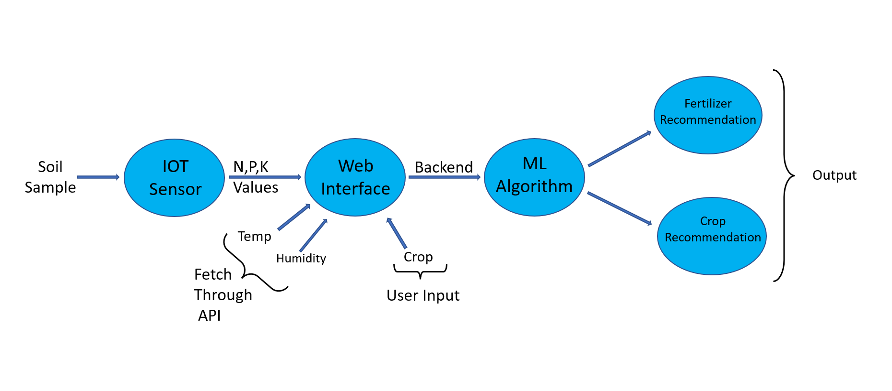
3.2 SYSTEM DESIGN USING DFD LEVEL 0 AND LEVEL 1

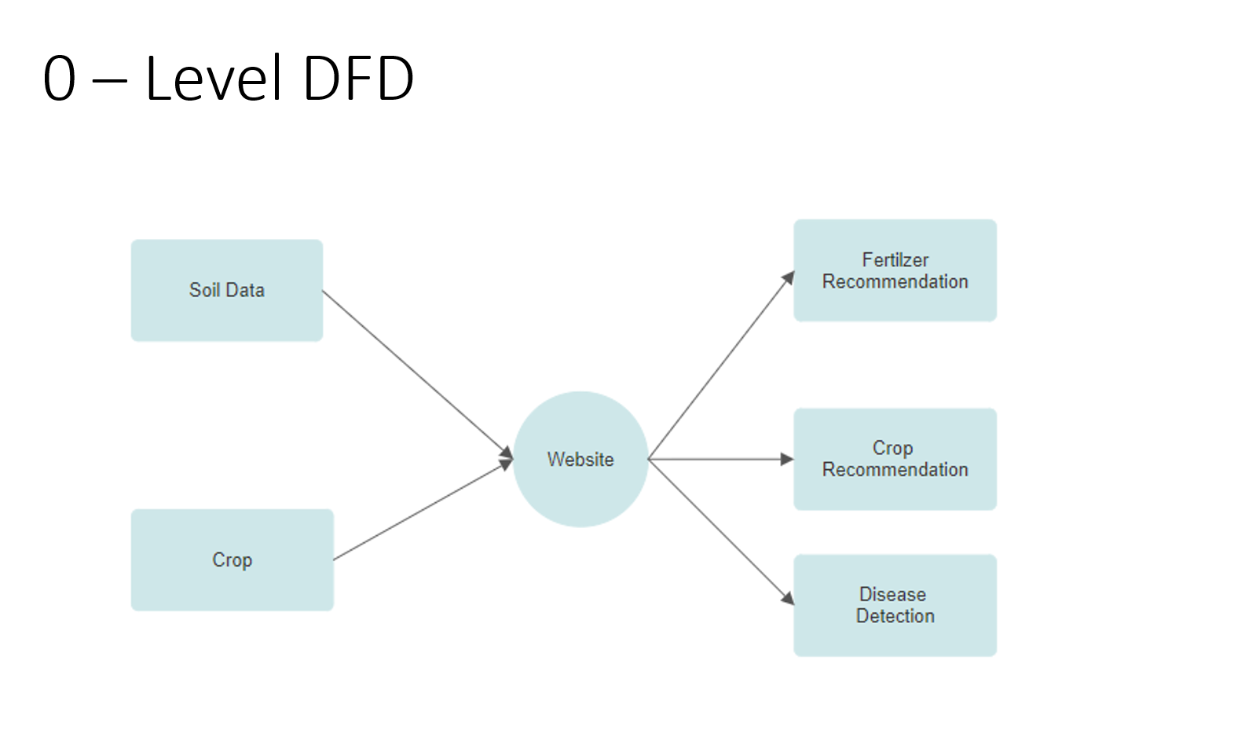
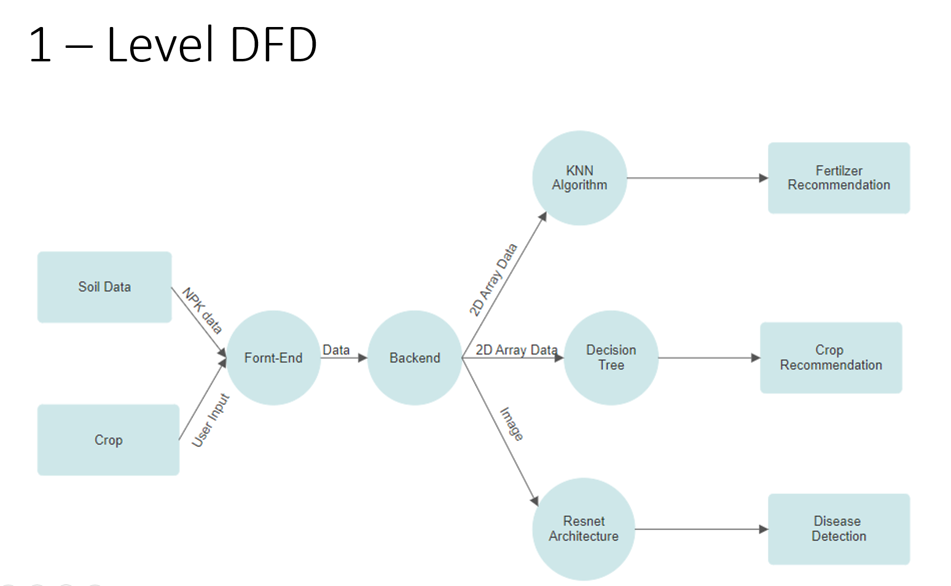

3.3 USE CASE DIAGRAM
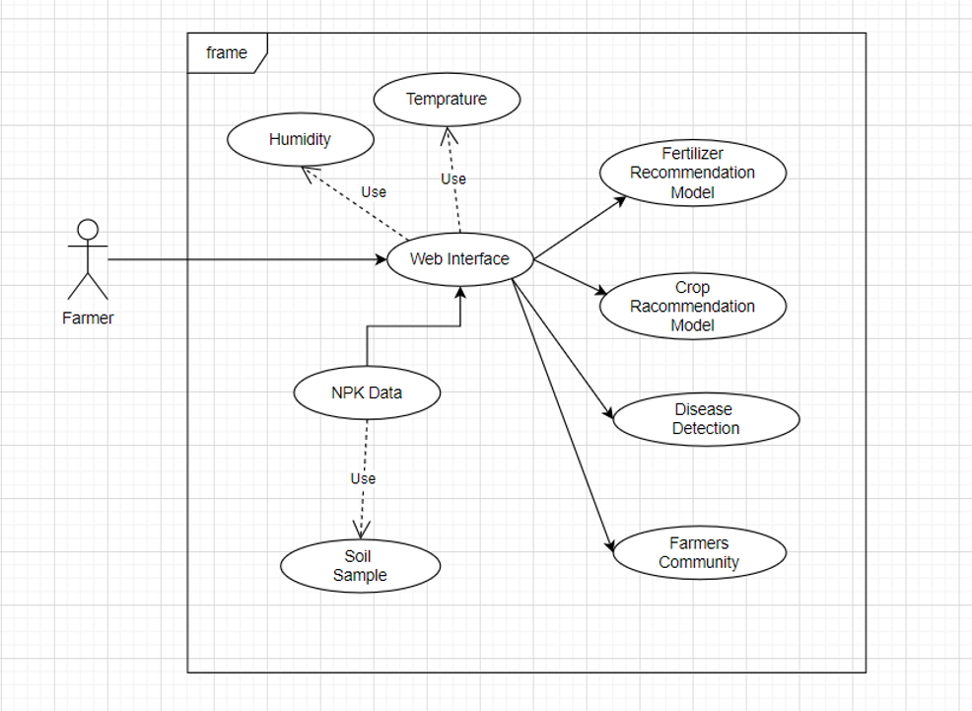

CHAPTER 4.
IMPLEMENTATION, TESTING, AND MAINTENANCE

4.1 INTRODUCTION TO LANGUAGES,TOOLS AND TECHNOLOGIES USED FOR IMPLEMENTATION

The implementation of the agricultural management system relies on a strategic selection of languages, tools, and technologies. Python is chosen for its versatility and integration with AI frameworks like TensorFlow, facilitating soil analysis and crop recommendation. Django serves as the backend framework, ensuring robustness and security. React.js is utilized for dynamic user interfaces, enhancing user experience. Git enables collaborative development, while Docker ensures seamless deployment. PostgreSQL manages relational data, and AWS provides scalable cloud infrastructure. This comprehensive stack aims to deliver a robust, scalable, and user-friendly solution tailored to the needs of modern agriculture.

4.2 TESTING TECHNIQUES AND TEST CASES USED

Testing plays a pivotal role in ensuring the reliability, functionality, and performance of the agricultural management system. Various testing techniques and test cases are employed throughout the development lifecycle to validate the system's behavior under different scenarios.
4.2.1 Testing Techniques:
- Unit Testing: Individual components such as AI algorithms, database queries, and web endpoints are tested in isolation to verify their correctness and functionality.
- Integration Testing: Interaction between system components, including data flow and communication protocols, is tested to ensure seamless integration and interoperability.
- User Acceptance Testing (UAT): End-users, including farmers and agricultural experts, validate the system's usability, functionality, and alignment with user requirements in real-world scenarios.
- Performance Testing: The system's response time, scalability, and reliability under various load conditions are evaluated to ensure optimal performance and responsiveness.
4.2.2 Test Cases:
- User Registration: Verify successful registration process with valid user details.
- Soil Nutrient Measurement: Validate accurate recording of NPK values from IoT sensors.
- Crop Recommendation: Ensure AI algorithm provides appropriate crop recommendations based on soil analysis.
- Weather Integration: Verify correct integration and display of real-time weather forecasts.
- User Interface Interaction: Test user interactions and data input through the web interface.
- Disease Detection: Validate disease detection algorithm's accuracy in identifying plant diseases from uploaded images.
- User Profile Update: Ensure successful updating of user profile information.
- Security Testing: Verify data encryption, authentication mechanisms, and access controls to prevent unauthorized access.
- Compatibility Testing: Validate system compatibility across different devices, browsers, and operating systems.
- Scalability Testing: Evaluate system performance and scalability under increasing user load and data volume.

CHAPTER 5
RESULTS AND DISCUSSIONS

5.1 USER INTERFACE REPRESENTATION (OF RESPECTIVE PROJECT)
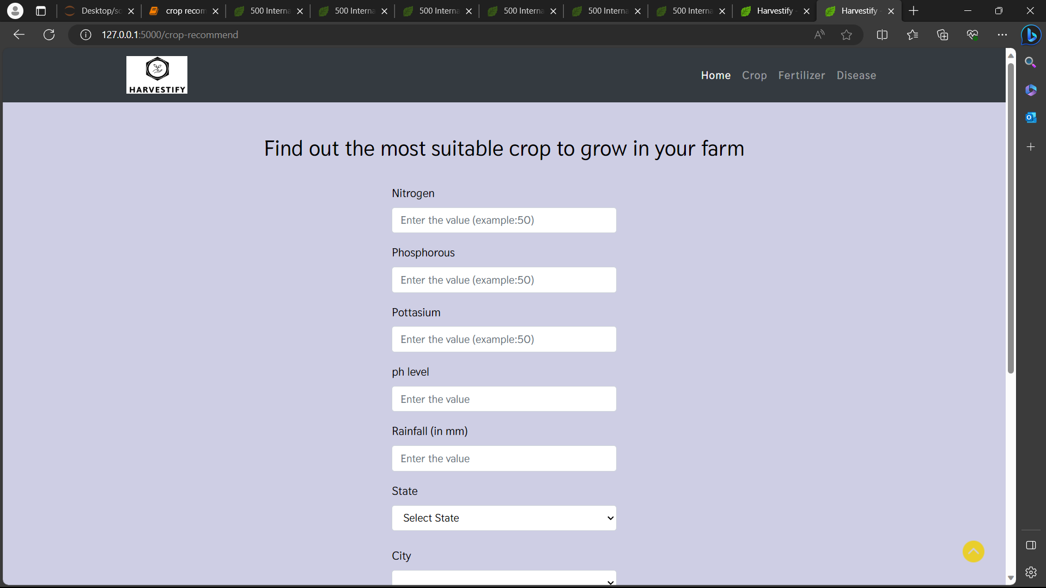

5.1.1 BRIEF DESCRIPTION OF VARIOUS MODULES OF THE SYSTEM
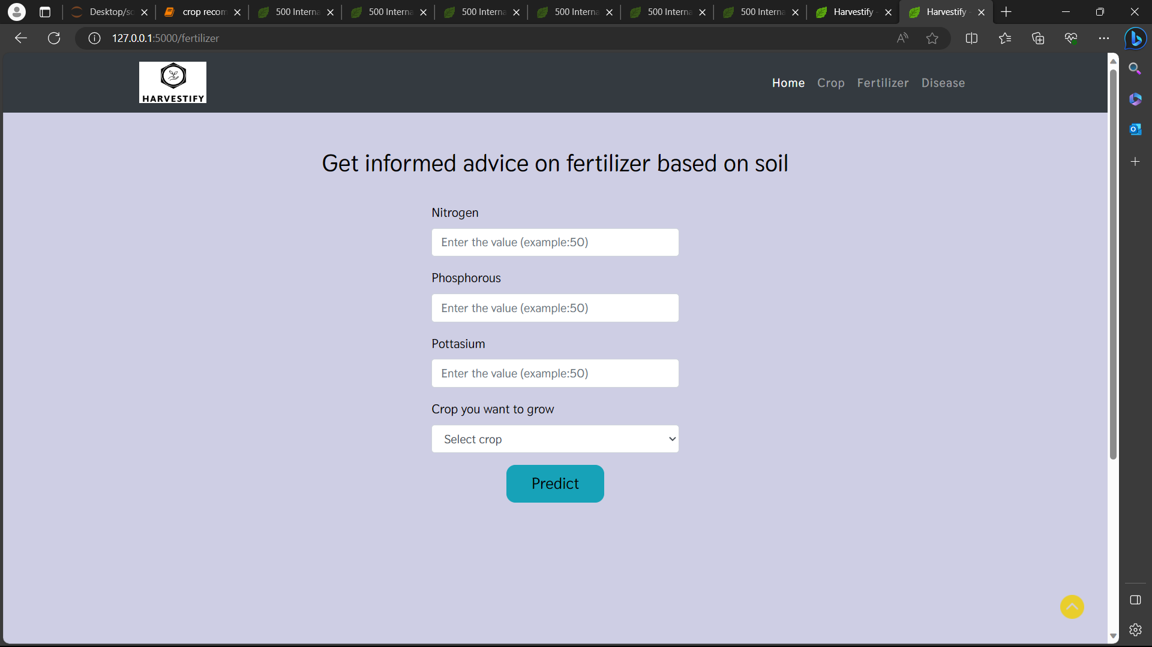

5.2 SNAPSHOTS OF SYSTEM WITH BRIEF DETAIL OF EACH

CHAPTER 6
CONCLUSION AND FUTURE SCOPE

6.1 Conclusion
The development and implementation of the agricultural management system mark a significant milestone in modernizing farming practices. Through the integration of advanced technologies such as IoT, AI, and machine learning, the system offers farmers a comprehensive toolkit for optimizing productivity, sustainability, and decision-making in agricultural operations. Key achievements of the project include real-time soil monitoring, AI-driven crop recommendations, weather integration, and disease detection capabilities. User feedback and testing have validated the system's functionality, usability, and reliability.
6.2 Future Scope
While the current system represents a robust and functional solution, there are several avenues for future enhancements and expansions:
- Weather Forecasting and Risk Management: Enhance weather forecasting capabilities to provide advanced risk assessment and mitigation strategies for farmers.
- IoT Sensor Integration: Integrate additional IoT sensors for monitoring other key agricultural parameters such as water levels, humidity, and pest activity.
- Machine Learning Algorithms: Continuously improve AI algorithms for crop recommendation and disease detection, incorporating more advanced data analytics and predictive modeling.
- Mobile Application Development: Develop a mobile application for farmers to access the system's features on-the-go, improving accessibility and convenience.
- Community Collaboration Platform: Expand the system to include a community collaboration platform where farmers can share insights, best practices, and solutions to common challenges.
- Blockchain Integration: Explore blockchain technology for enhanced data security, transparency, and traceability in agricultural transactions and supply chains.
By focusing on these future scope areas, the agricultural management system can further empower farmers, promote sustainable practices, and drive innovation in the agriculture sector. Ongoing collaboration with agricultural experts, continuous user feedback, and technological advancements will be instrumental in realizing these future enhancements and ensuring the system's long-term success.

REFERENCES

[1] isi.edu/nsnam/ns/tutorial Marc Greis tutorial on ns2 on, 12 October 2013.

[2] Matthias Transier “Ns2 tutorial running simulations”.

[3] D. Kim, J. Garcia and K. Obraczka, “Routing Mechanisms for Mobile Ad Hoc Networks based on the Energy Drain Rate”, IEEE Transactions on Mobile Computing. Vol 2, no 2, 2003, pp.161-173.

[4] C.E. Perkins & P. Bhagwat, “Highly Dynamic Destination Sequence-Vector Routing (DSDV) for Mobile Computers”, Computer Communication Review, vol. 24, no.4, 1994, pp. 234-244.

[5] C.E. Perkins and E.M. Royer, “Ad-Hoc on-Demand Distance Vector Routing,” Proc. Workshop Mobile Computing Systems and Applications (WMCSA ’99), Feb. 1999 pp. 90-100.

[6] David B. Johnson and David A. Maltz. “Dynamic source routing in ad hoc wireless networks”, Mobile Computing, Kluwer Academic Publishers. 1996 pp.153–181, 1996.

[7] M. S. Corson, J. P. Maker and G. H. Cirincione , "Internet-Based Mobile Ad Hoc Networking," IEEE Internet Computing, Vol. 3, no. 4, July-August 1999, pp. 63-70.

[8] V. Ramesh, Dr. P. Subbaiah, N. Koteswar Rao and M. Janardhana Raju,"Performance comparison and analysis of DSDV and AODV for MANET," (JJCSE) International Journal on Computer Science and Engineering , vol. 02 , pp. 183-188, 2010 Md. Monzur Morshed; Franz I. S. Ko; Dongwook Lim; Md. Habibur Rahman; Md. Rezaur Rahman Mazumder; Jyotirmoy Ghosh.

